 [Translated from German to English - www.onlinedoctranslator.com](https://www.onlinedoctranslator.com/en/?utm_source=onlinedoctranslator&utm_medium=docx&utm_campaign=attribution)

**1 Mechanics**

Long conveyor belt Technical documentation

C by Dr.-Ing. Paul Christiani GmbH & Co. KG 1

**1.1 Functional description**

The conveyor belt functional assembly consists of a 680 mm long and 50 mm wide belt section. A sensor (light sensor with fiber optic amplifier) ​​is installed at the end of the conveyor belt section, which starts or stops the conveyor belt as soon as a workpiece is detected by the sensors. The conveyor belt can be moved alternately in both directions using a reversing contactor circuit.

The functional assembly is completely constructed on two mounting platforms and can be flexibly mounted individually or together with other functional assemblies on an aluminum profile plate.

A 24-volt DC motor, two motor relays for setting up a reversing contactor circuit, and two 8-bit transfer connectors are available for operation. One digital input and two digital outputs should be available on the PLC to connect the function module.

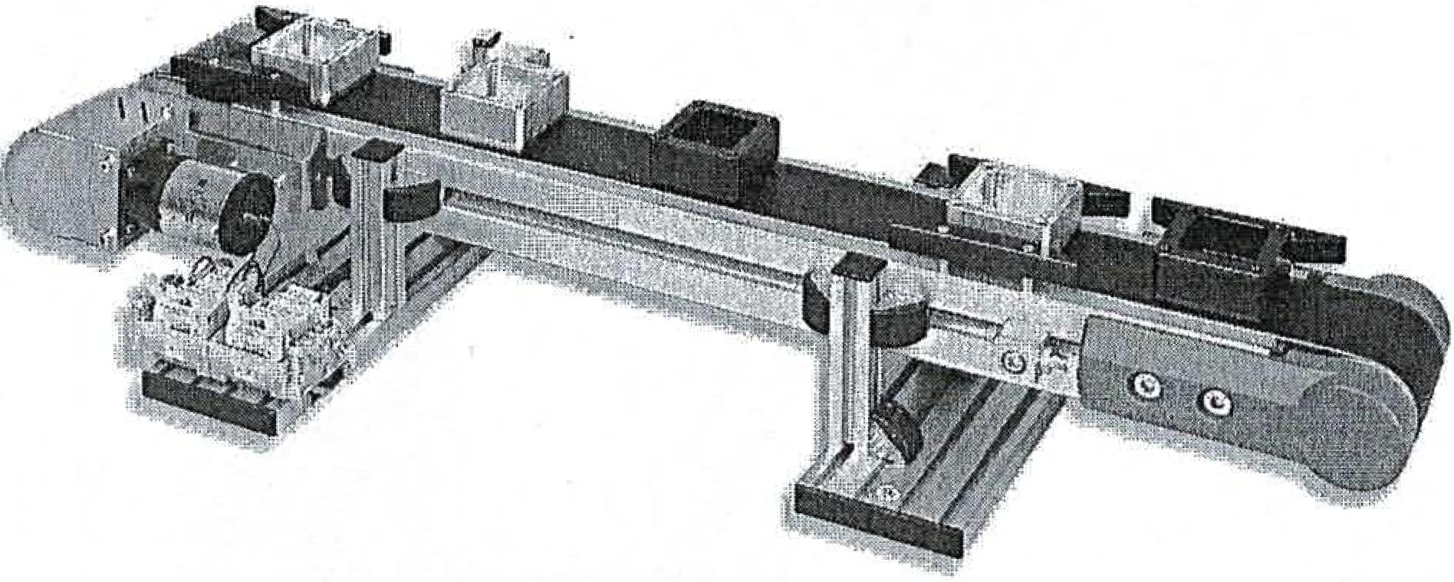

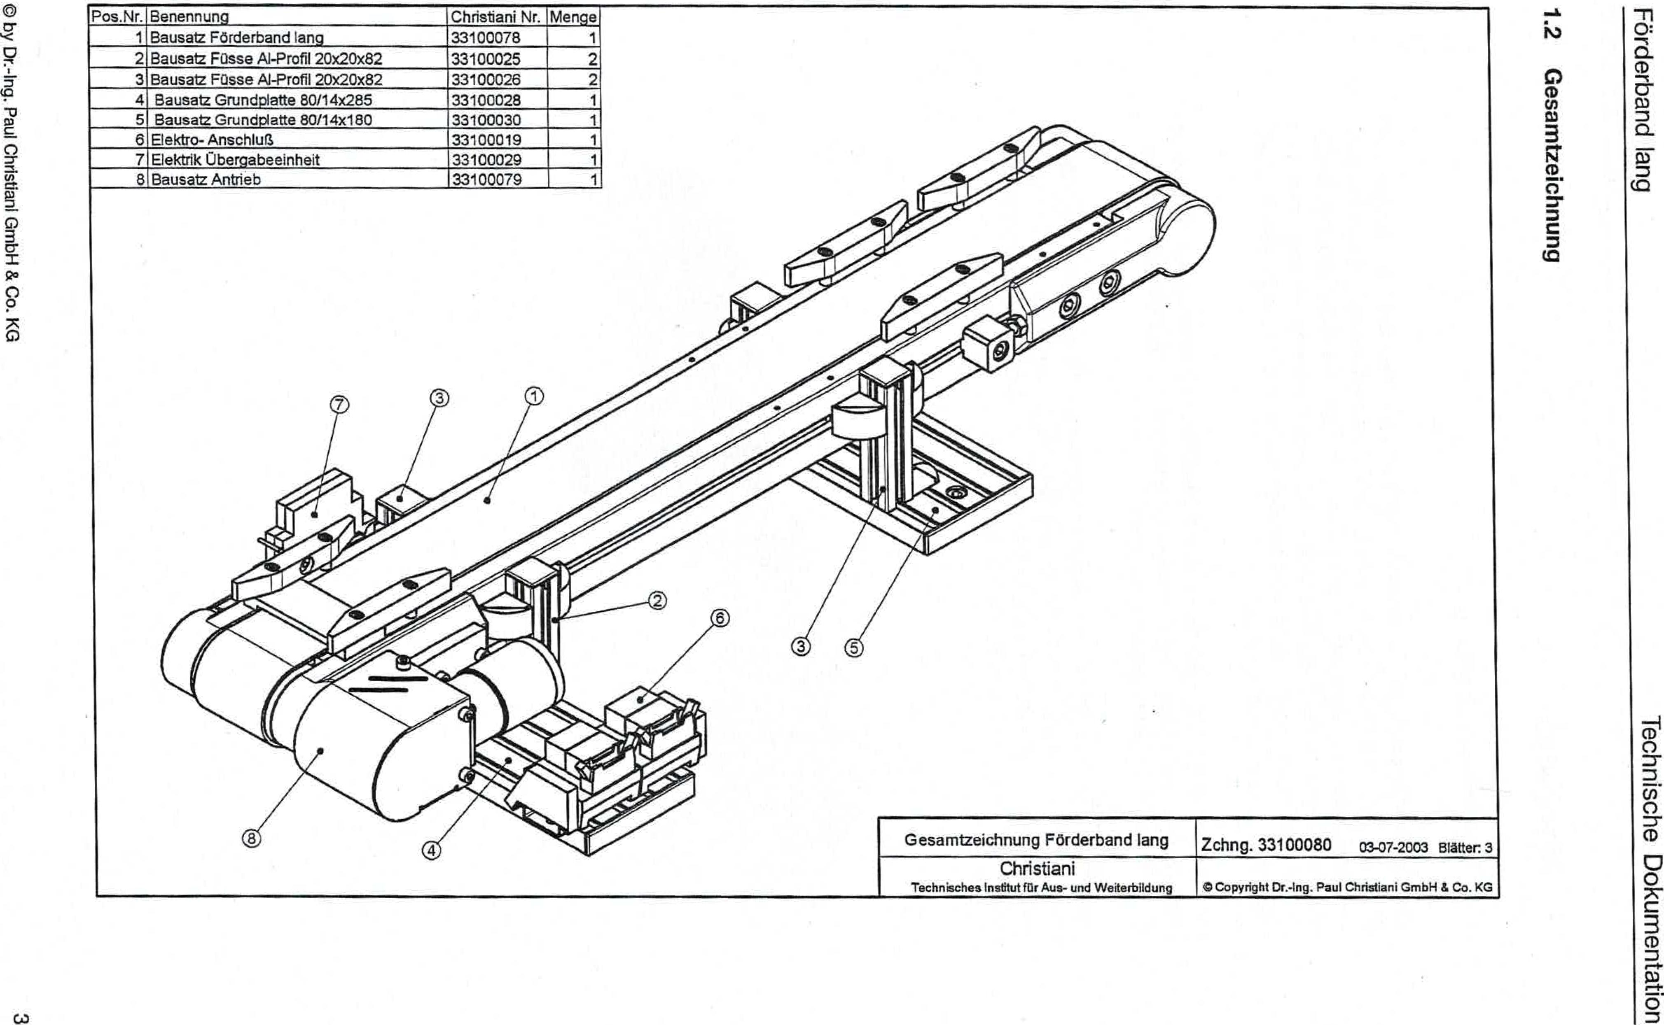

THERE-o3 2 !--iquip iuunspLio ined *6uv.10 Aq 0

GJ

**6unut1a1aziweseo**

IV

Your puectiamd

uopluawnloo apsrugoai

33100019

6 Electrical connection

7

133100029

8

Electrical transfer unit

33100079

1

Drive kit

Item No. Description

1 long conveyor belt kit

2 kit feet Al-profile 20x20x82

Kit feet Al-profile 20x20x82

Base plate kit 80/14x285

5 Kit base plate 80/14x180

Christiani No. 1 Quantity

33100078 1

33100025

33100026

33100028

33100030

3

4

2

2

1

General drawing of long conveyor belt

Christiani

Technical Institute for Education and Training

Drawing 33100080 03—D7-2003 Sheets.3

0 Copyright Dr.-Ing. Paul Christian' GmbH & Co. KG

1

1

1